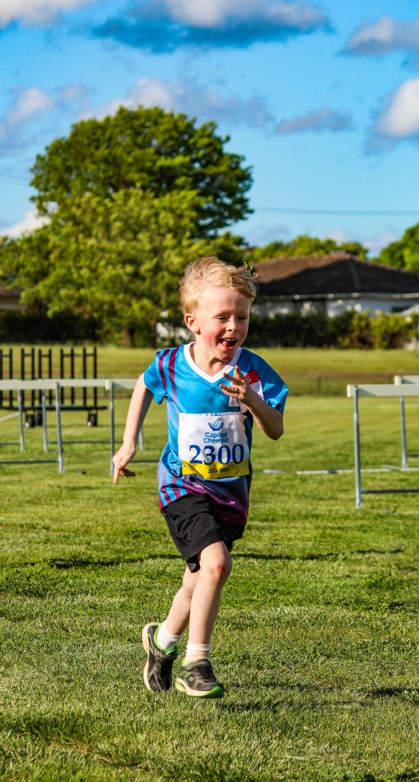

# ATHLETES

1. 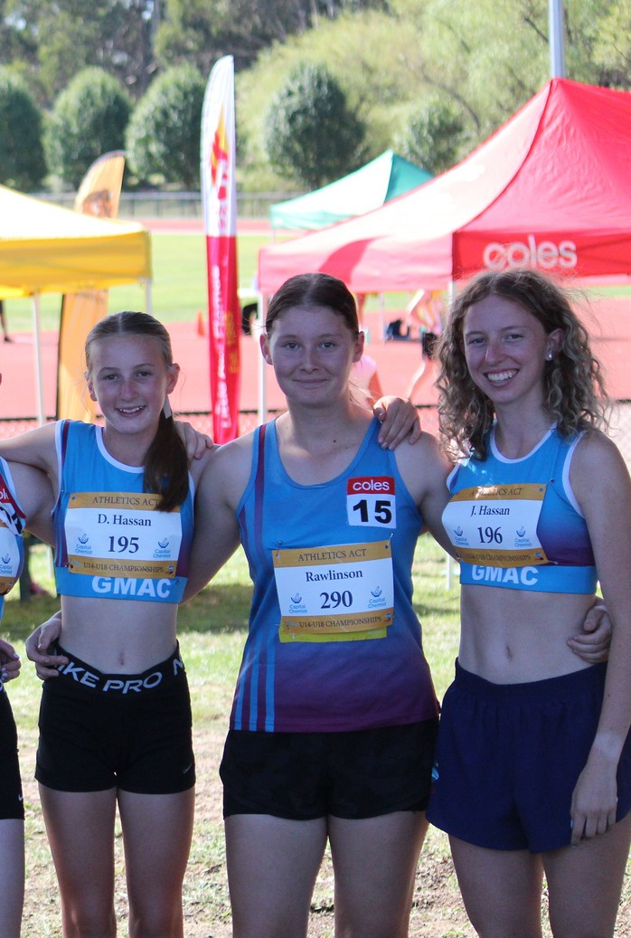Compete according to the rules.

**(Adapted from the Australian Sports Commissions’ Junior Sport Codes of Behaviour)**

# BEHAVIOURAL GUIDELINES

## These Behavioural Guidelines aim to give everyone a guide to what is expected of them if they are part of Little Athletics, be it participating, volunteering, or standing on the sideline cheering for their child, relative or friend. The guidelines set down what is an acceptable standard of conduct and behaviour and reflect the principles upon which Little Athletics is based.

Acceptance of, and compliance with these guidelines will ensure that Little Athletes will develop good sporting behaviours and have an enjoyable sporting experience, encouraging them to remain involved in sports or otherwise be active throughout their lives.

## We ask that everyone takes the time to read the guidelines and make a personal commitment to always behave in accordance.

1. Work equally hard for yourself and/or the centre.
2. Always address officials in a polite manner.
3. Be a good sport. Acknowledge all good results, whether they are made by your centre or friends or an athlete from another centre.
4. Only cheer good performances, not when other competitors make an error or don’t perform well.
5. Treat other competitors with respect.
6. Do not act smart or ‘cocky’.
7. Treat all athletes as you like to be treated. Do not bully or take unfair advantage of another competitor.
8. Cooperate with your coach, centre-mates, and other competitors. Without them, there would be no competition.
9. Participate for your own enjoyment and benefit, not just to please parents and coaches.
10. Remember that all that is ever requested of you is to try your best.

# PARENTS, RELATIVES & SPECTATORS

1. Remember that young people are involved in

Little Athletics for their enjoyment, not yours.

1. Encourage children to participate, do not force them.
2. Focus on the child’s efforts and performances rather than winning or losing.
3. Encourage athletes to always participate according to the rules.
4. Applaud good performances and efforts from all competitors.
5. Support all efforts to remove verbal abuse from Little Athletics. Condemn the use of violence in any form, whether it is by spectators, coaches, officials or athletes.
6. Recognise the value and importance of being a volunteer.
7. Respect officials decisions and teach young people to do likewise. Remember, officials freely give their time and effort for your child’s involvement and enjoyment.
8. Show appreciation for volunteer coaches, officials, and administrators. Without them, your child could not participate.

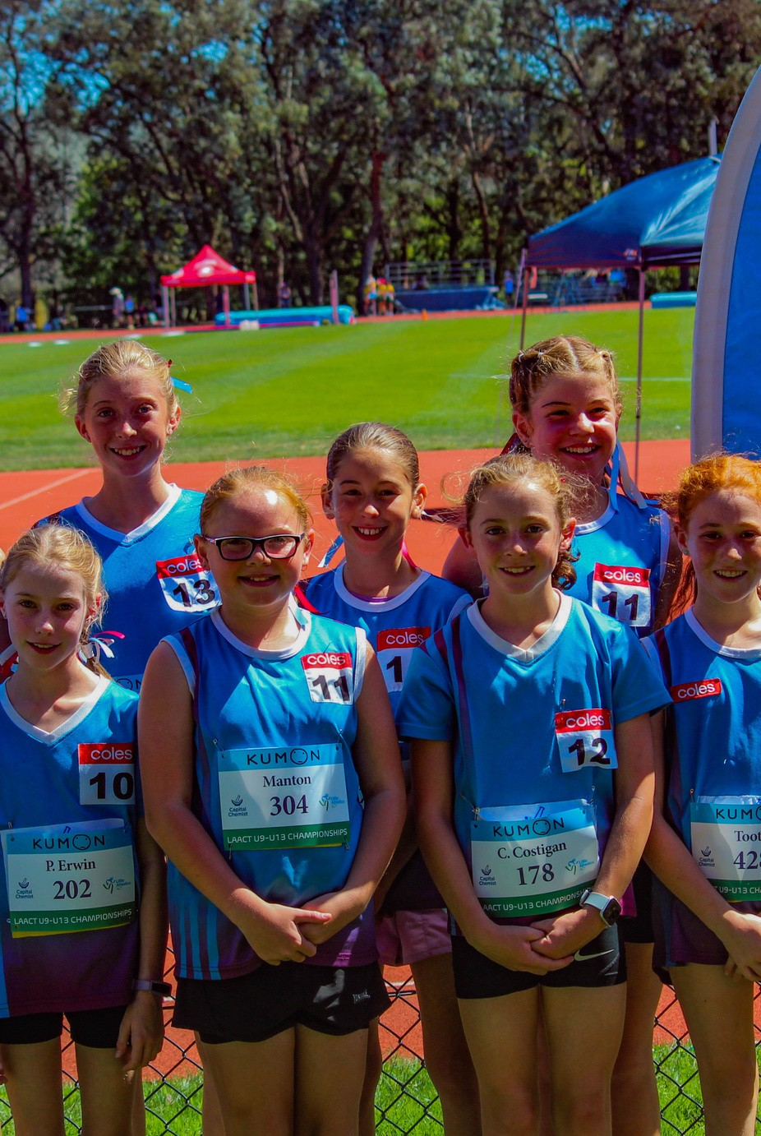

# OFFICIALS

1. 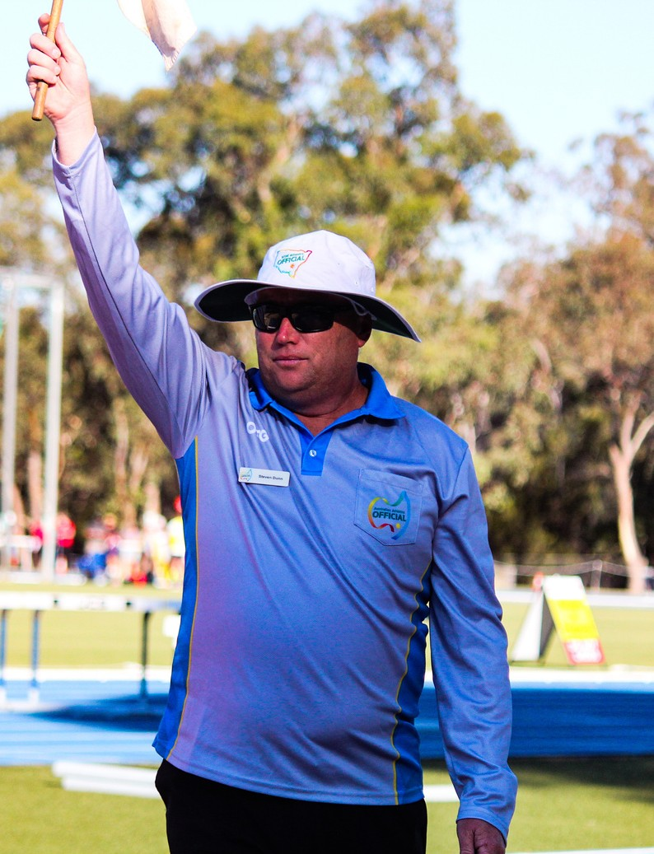Officiate according to the rules and where subjective judgment is necessary, decide on the basis of what is fair to all athletes. Be impartial.
2. Be consistent, objective and courteous when making decisions.
3. Avoid any situations which may be perceived as a conflict of interest.
4. Accept responsibility for all actions taken. If you make a mistake, admit it.
5. Condemn unsporting behaviour and promote respect for all competitors.
6. Emphasise the spirit of the competition rather than the errors. Do not over-officiate.
7. Ensure that your behaviour and comments are always positive and supportive.
8. Keep up to date with the latest trends in officiating and the principles of growth and development of young people.
9. Place the safety and welfare of the athletes above all else.

# COACHES

* 1. Remember that young people participate for fun and enjoyment and winning is only part of their motivation.
  2. Be reasonable in your demands on the young athlete’s time, energy, and enthusiasm.
  3. Operate within the rules and spirit of Little Athletics and teach your athletes to do the same.
  4. Ensure that the time athletes spend with you is a positive experience. All young people are deserving of equal attention and opportunities.
  5. Avoid over-attention to the talented athletes; the ‘just-average’ need and deserve equal time.
  6. Ensure that equipment and facilities meet relevant safety standards and are appropriate to the age and ability of all athletes.
  7. Display control, respect, and professionalism to all involved with Little Athletics. Encourage athletes to do the same.
  8. Explain to athletes and their parents what you are aiming to achieve and why.
  9. Show concern and caution toward sick and injured athletes. Follow medical advice when determining whether an injured athlete is ready to recommence training and competition.
  10. Obtain suitable qualifications to keep up to date with the latest coach practices and the principles of growth and development of young people.

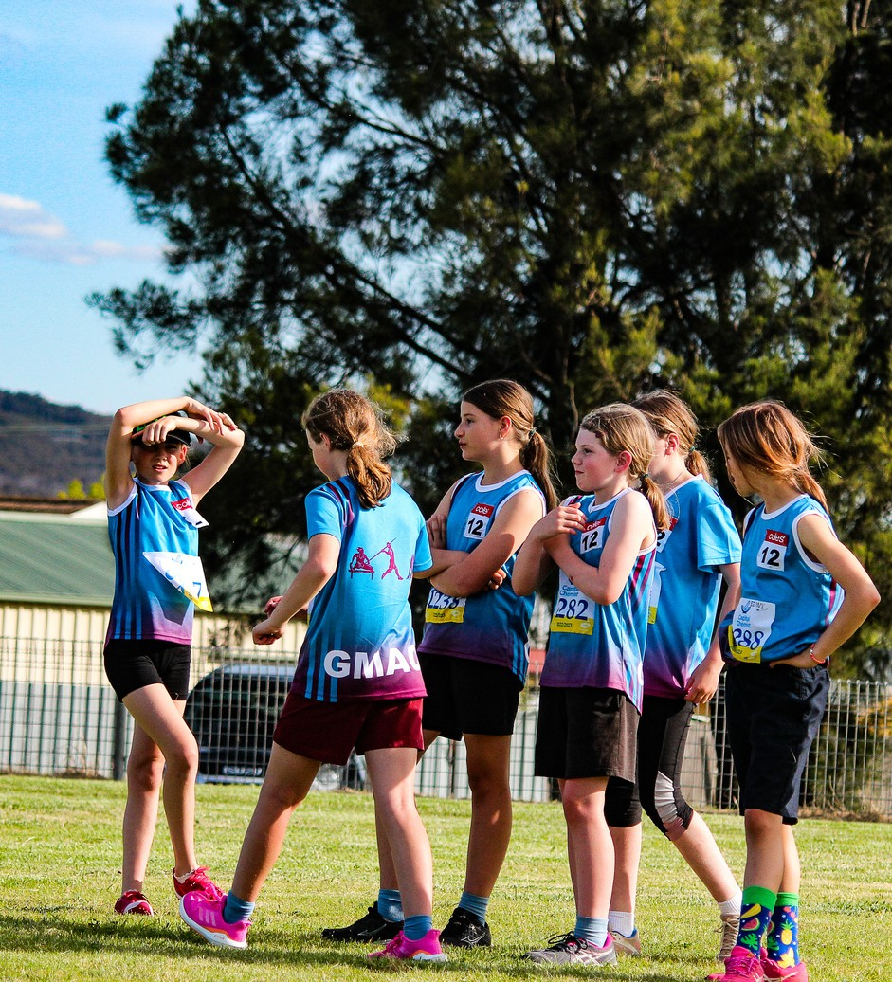

# ADMINISTRATOR

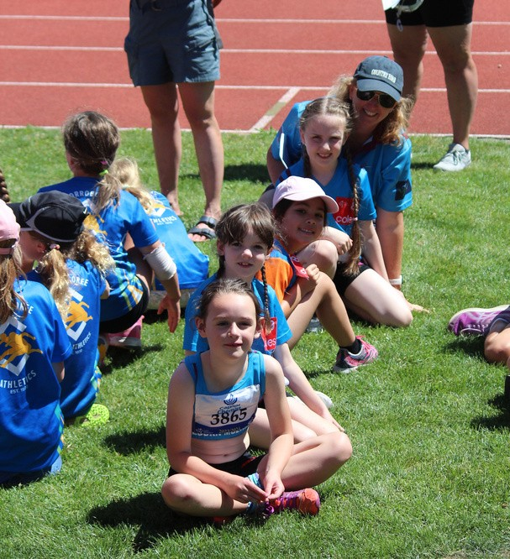

1. Ensure all young people have equal opportunities for participation.
2. Ensure that rules and equipment are modified to suit the age, ability and maturity level of athletes and that equipment.
3. Provide quality supervision and instruction.
4. Be fair, considerate and honest in all dealings.
5. Resolve conflicts fairly and promptly through established procedures.
6. Remember that young people participate for their enjoyment and benefit. Do not over emphasise awards.
7. Support the efforts of coaches and officials and help improve the standards of coaching and officiating.
8. Involve where appropriate, members in planning, leadership, evolution and decision making related to the actual activity.
9. Ensure that everyone involved in Little Athletics emphesise ‘fair play’ and not winning at all costs.
10. Develop Codes of Conduct and Behavioural Guidelines and encourage everyone to follow them.
11. Make it clear that abusing young people in any way is unacceptable and will result in reporting and appropriate action.